IBM Training Day-1

Q1. write a program to input radius and print area.

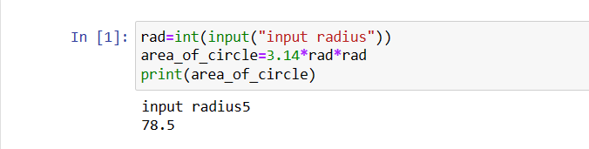

Q2. wap to input 3 numbers and calculate their average and print it. also print the percente of marks?

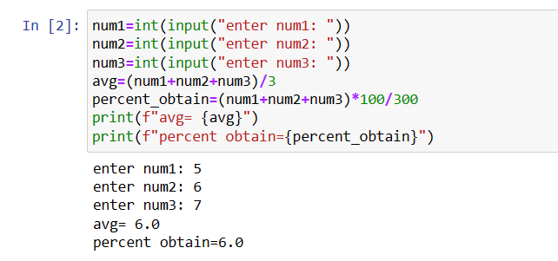

Q3. write a program to calculate bmi.

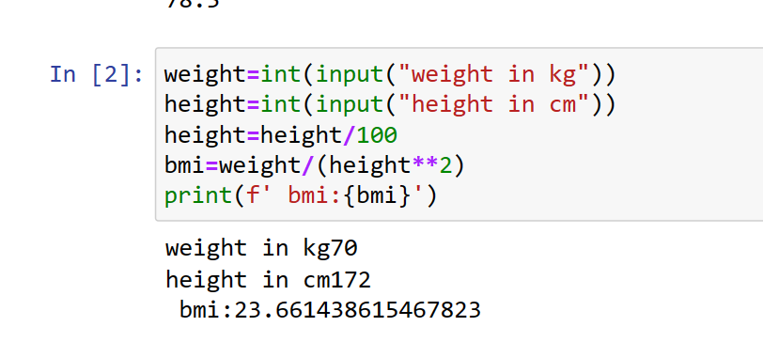

Q4. write a program to print simple intrest.

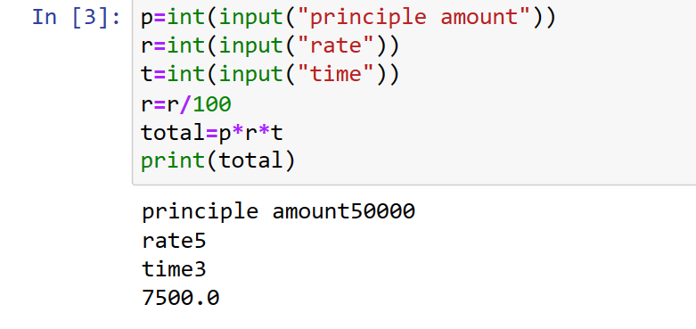

Q5. wap to input temp in celsius and then convert into Fahrenheit.

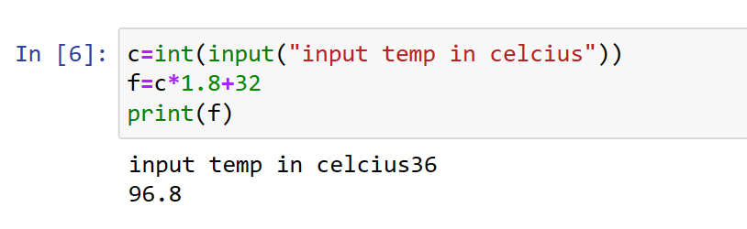

Q6.WAP to calculate EMI.

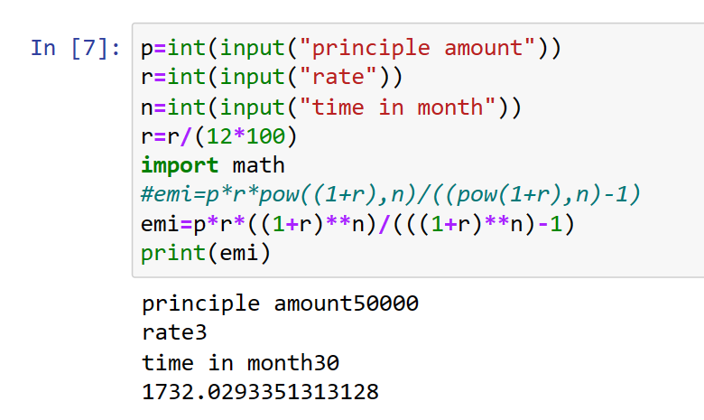

Q7.wap to convert Celsius into kelvin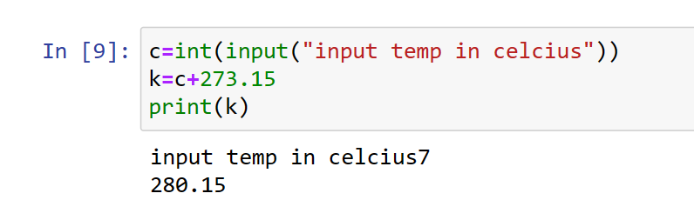

Q8.wap to print area of trianglr using heron's formula

by taking all side input

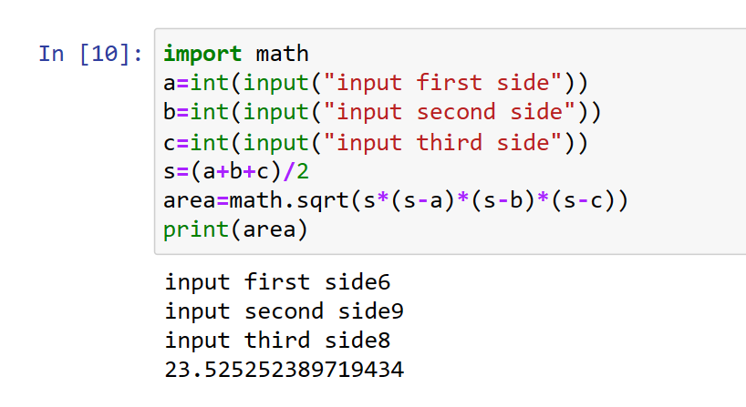

Q9. wap that reads a number of seconds and prints it in form mins and second.

E.g. 200 sec are printrd as 3min and 20 sec

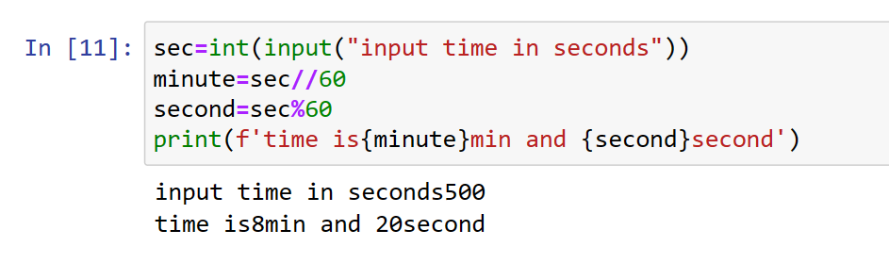

Q10. wap to generate the following output:

5

10

9

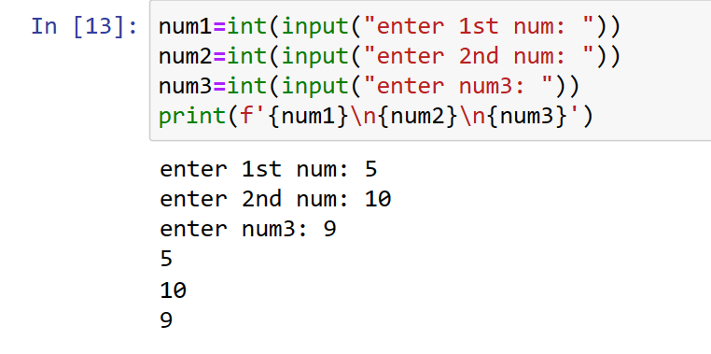

Q11. modify the above program so as to print output as 5@10@9

